DABUUS NURSERY AND PRIMARY SCHOOL
SCHEME OF WORK FOR MIDDLE CLASS – NUMBERS TERM III 2023
W  K | PD | LEARNING OUTCOME | MAJOR COMPETENCE | SPECIFIC COMPETENCE | CONTENT | ACTIVITIES | METHODS | T/L AIDS | REF | REM
1 | 1 | Recognizing, describing and representing numbers and their relationships and solving mathematical problems with confidence and competence | I can count things and numbers (1 – 30) | I can count and write numbers (1 – 30) | Numbers 1 – 30  Copy and learn number words  One , 1 six 6 eight 8 five 5 two 2 zero 0 seven 7 three 3 ten 10 four 4 | Reciting numbers 1 – 50  Identifying numbers 1 – 50  Reading and writing | Guided discovery  Question and answer  Illustration  Demonstration | Counters  Chalkboard illustration  Chart with numbers 1 – 30 | LFW  Page
1 | 2 |  | I can count things and numbers (1 – 30) | I can match numbers to their number words | Introduce number words one – ten  Read and match  one 2  six 8  eight 6  two 1 etc
1 | 3 |  | I can count things and numbers (1 – 30) | I can count objects and write its number word (name | Write the number words  1 ______ 6 ____  3 _____ 4 ____  0 ______ 2 ____  7 _____ |  |  | Counters  Chalkboard illustration  Chart with numbers 1 – 30 | LFW page
1 | 4 |  |  | I can count objects and write its number word (name | Count and write in numbers and words.   ______ ________  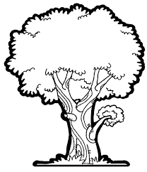_____ _______  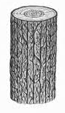______ _______  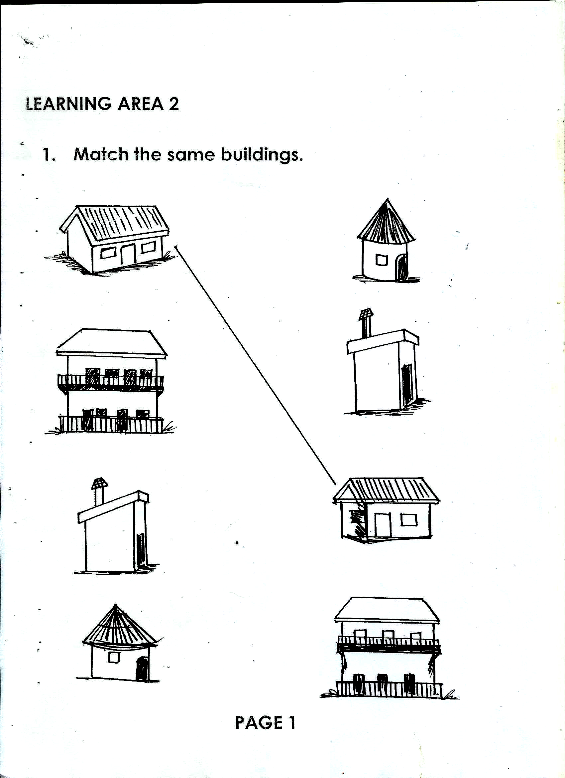____ ______  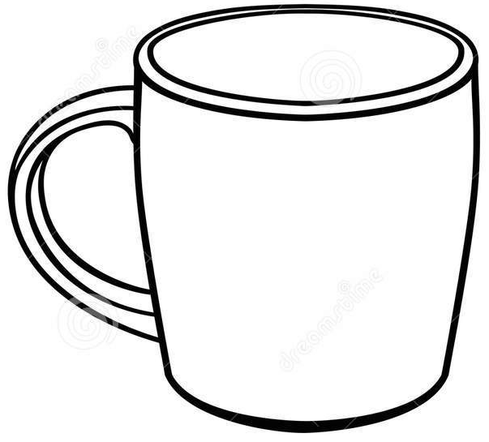 ____ ___  Read and draw for the numbers  2 two _____ 7 seven ____  6 six ____ 1 one _____  0 zero _____ 5 five _____  3 three ____ 4 four ____ |  |  |  | LFW page
2 | 1 |  |  |  | Write in figures  One ____  three ____  six ____ etc |  |  |  | LFW page
2 | 2 |  |  |  | Form new numbers  2 and 0 = 20 upto  2 and 5 = 25 |  |  |  | LFW page
2 | 3 | Recognizing, describing and representing numbers and their relationships and solving mathematical problems with confidence and competence |  |  | Form numbers  2 and 6 = 26 upto  3 and 0 = 30 |  |  |  | LFW page
2 | 4 |  |  | I can identify, match the same and write | Match the same & write 11 upto 20 and write  11 13 ___  12 12 ____  13 11 ___ |  |  |  | LFW page
3 | 1 |  |  | I can complete the sequence | Complete the sequence  20, _____ ____ ______  upto 25 |  |  |  | LFW page
3 | 2 |  |  | I can identify and form new numbers 3 and 0 = 30 upto 3 and 5 = 35 | Copy number 30 – 35  30 ___ ____ ____  31 ___ ___ ___ upto 35 | - Reciting numbers (1 – 50)  - Identify and reading given numbers  - Writing accordingly |  |  | LFW page
3 | 3 |  |  | I can form new numbers 10 – 50 | Form numbers  1 and 0 = 10  Upto 50 |  |  |  | LFW page
3 | 4 |  |  | I can identify match the same numbers and write | Copy numbers 1 – 50  1, 2, 3, 4, …….. up to 50 |  |  |  | LFW page
4 | 1 | Recognizing, describing and representing numbers and their relationships and solving mathematical problems with confidence and competence |  | I can fill in the missing numbers | Fill in the missing number  15 __ ___ __ ___  20 ___ ___ ___ ___ |  | Look and say  Guided discovery  Illustration  Demonstration | Chalk board illustration  Chart with numbers (1 – 30) | LFW page
4 | 2 |  |  | I can listen and write | Listen and write (select numbers randomly) |  | Look and say  Guided discovery  Illustration  Demonstration | Chalk board illustration  Chart with numbers (1 – 30) | LFW page
4 | 3 |  |  | I can identify and write the next number | Write the next number  21 ___ ___ ____ ____  25 ___ ___ ____ ___ ___  30 ___ ___ ___ ___ ___ |  | Look and say  Guided discovery  Illustration  Demonstration | Chalk board illustration  Chart with numbers (1 – 30) | LFW page
4 | 4 |  |  | I can copy numbers (20 – 50) | Copy numbers 20 upto 50 | - Reciting numbers 1 – 50  - Identifying and copying numbers (1 – 40 | Look and say method  Guided discussion  Guided discovery
5 | 1 |  |  | I can count and draw for the number | Count and draw the beads for the numbers  4 3 0 2 |  | Look and say method  Guided discussion  Guided discovery
5 | 2 |  |  | I can add objects and numbers | Addition of objects  + = etc |  | Look and say method  Guided discussion  Guided discovery
5 | 3 |  |  | I can add objects and numbers  I can add numbers | Addition of objects  + =  + = etc |  | Look and say method  Guided discussion  Guided discovery
5 | 4
6 | 1 |  | I can name objects of different shapes | I can read and draw the shapes | Shapes  Read and draw  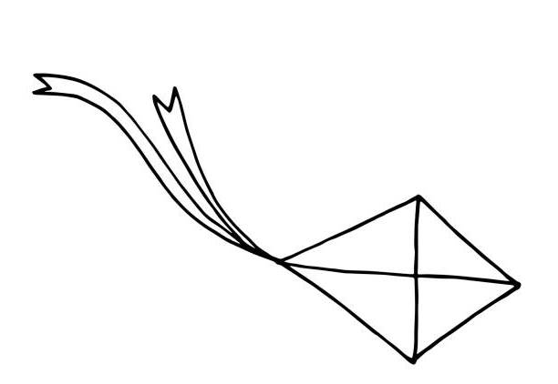kite  square  circle etc | - Recognizing shapes  - Talk about shapes  - Read and spell the words  - Draw them  Name the shapes |  |  | LFW page
6 | 2
6 | 3 | I can identify relationships and differences between objects and numbers | I can name objects of different shapes | I can read and draw the shapes | Name the shapes  square  circle etc | - Recognizing shapes  - Talk about shapes  - Read and spell the words  - Draw them  - Name the shapes
6 | 4 |  |  |  |  |  |  |  | LFW page
7 | 1 | Surveying knowing and distinguishing the attributes of objects | I can name objects of different shapes | I can identify the given shapes, read and match | Read and match the shapes | - Recognizing the shapes  - Reading and spelling the shapes names |  |  | LFW page
7 | 2 |  | I can name objects of different shapes | I can identify the given shapes, read and match | Shade the shapes according to colour  Red star  Blue zigzag  Etc
7 | 3 |  | I can name objects of different shapes | I can recognize various colours | Read and shade  yellow   green 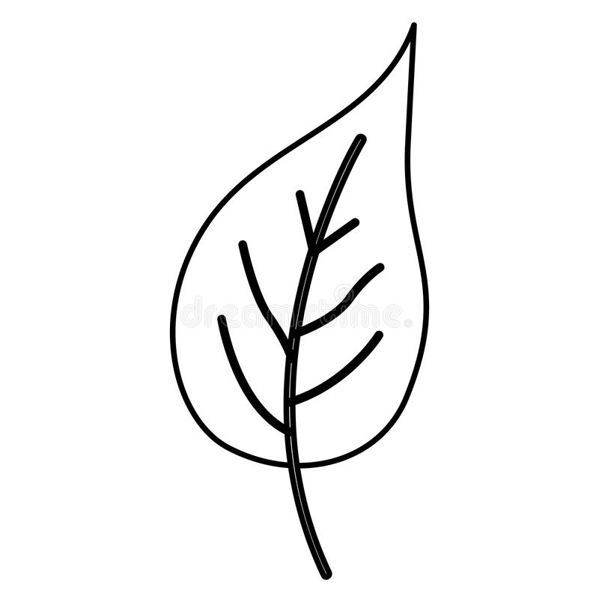  Etc
7 | 4 | Surveying knowing and distinguishing the attributes of objects |  |  | Read and colour the balloons  red blue green  black yellow pink |  |  |  | LFW page
8 | 1 | Surveying knowing and distinguishing the attributes of objects | I can identify the relationship and difference between objects | I can recognize the various colours | Match and write the objects colour  Red | - Reciting the rhyme about colours  - Identify the given colours  - Reading and spelling the colour names  - Match and writing the colour name |  |  | LFW page
8 | 2 | Recognizing, describing and representing numbers and their relationships and solving mathematical problems with confidence and competence | I can tell, more equal and less objects in quantities | I can recognize and circle the bigger number | Circle the bigger no.  7 9  6 8  3 5  2 1  10 12 | - Reciting numbers 1 – 30 |  |  | LFW page
8 | 3 |  | I can tell, more equal and less objects in quantities |  | Circle the bigger no.  7 4  2 8  3 9  5 1  10 15 |  |  |  | LFW page
8 | 4 |  | I can tell, more equal and less objects in quantities | I can form sets | Sets  A set of pens  A set of cups  A set of pots  A set of flowers |  |  |  | LFW page
9 | 1 | Recognizing, describing and representing numbers and their relationships and solving mathematical problems with confidence and competence | I can count things and numbers 1 – 30 | I can form sets |  | Reciting number rhymes  Forming sets practically  Counting objects in each set  Name the sets | Look and say  Illustration  Guided demonstration |  | LFW page
9 | 2 |  | I can count things and numbers 1 – 30 | I can form sets | Count and name the sets.  A set of two tins  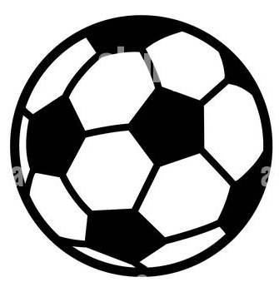 A set of four balls  Etc |  | Look and say  Illustration  Guided demonstration |  | LFW page
9 | 3 |  | I can count things and numbers 1 – 30 | I can form sets | Read and draw  A set of two tins  A set of three books  A set of five mats.
9 | 4 |  | I can count things and numbers 1 – 30 | I can form sets |  |  | Look and say  Illustration  Guided demonstration |  | LFW page

